**Assignment # 1**



**Fall 2023**

**CSE-402 Digital Signal Processing**

Submitted by: **Ali Asghar**

Registration No.: **21PWCSE2059**

Class Section: **C**

“On my honor, as student of University of Engineering and Technology, I have neither given nor received unauthorized assistance on this academic work.”

Submitted to:

**Engr. Ihsan Ul Haq**

Date:

**24th October 2023**

**Department of Computer Systems Engineering**

**University of Engineering and Technology, Peshawar**

**Task:**

Write MATLAB code to generate output graphs for exponential sequences for Real and Complex parameters.

• Using Equations **x[n] = A α^n** for Real Graphs.

• Using Equations **x[n]=|A |e j(ω0n+φ) = |A | cos (ω0n + φ) + j |A |sin (ω0n + φ)** for Complex Graphs.

**Real Exponential:**

Let A=1.5, n= -10 to 10

1. for (alpha = -1), try alpha= -1
2. for (0 < alpha < 1), try alpha=0.7
3. for (|alpha| > 1), try alpha= 1.1

**Code:**

**Output:**

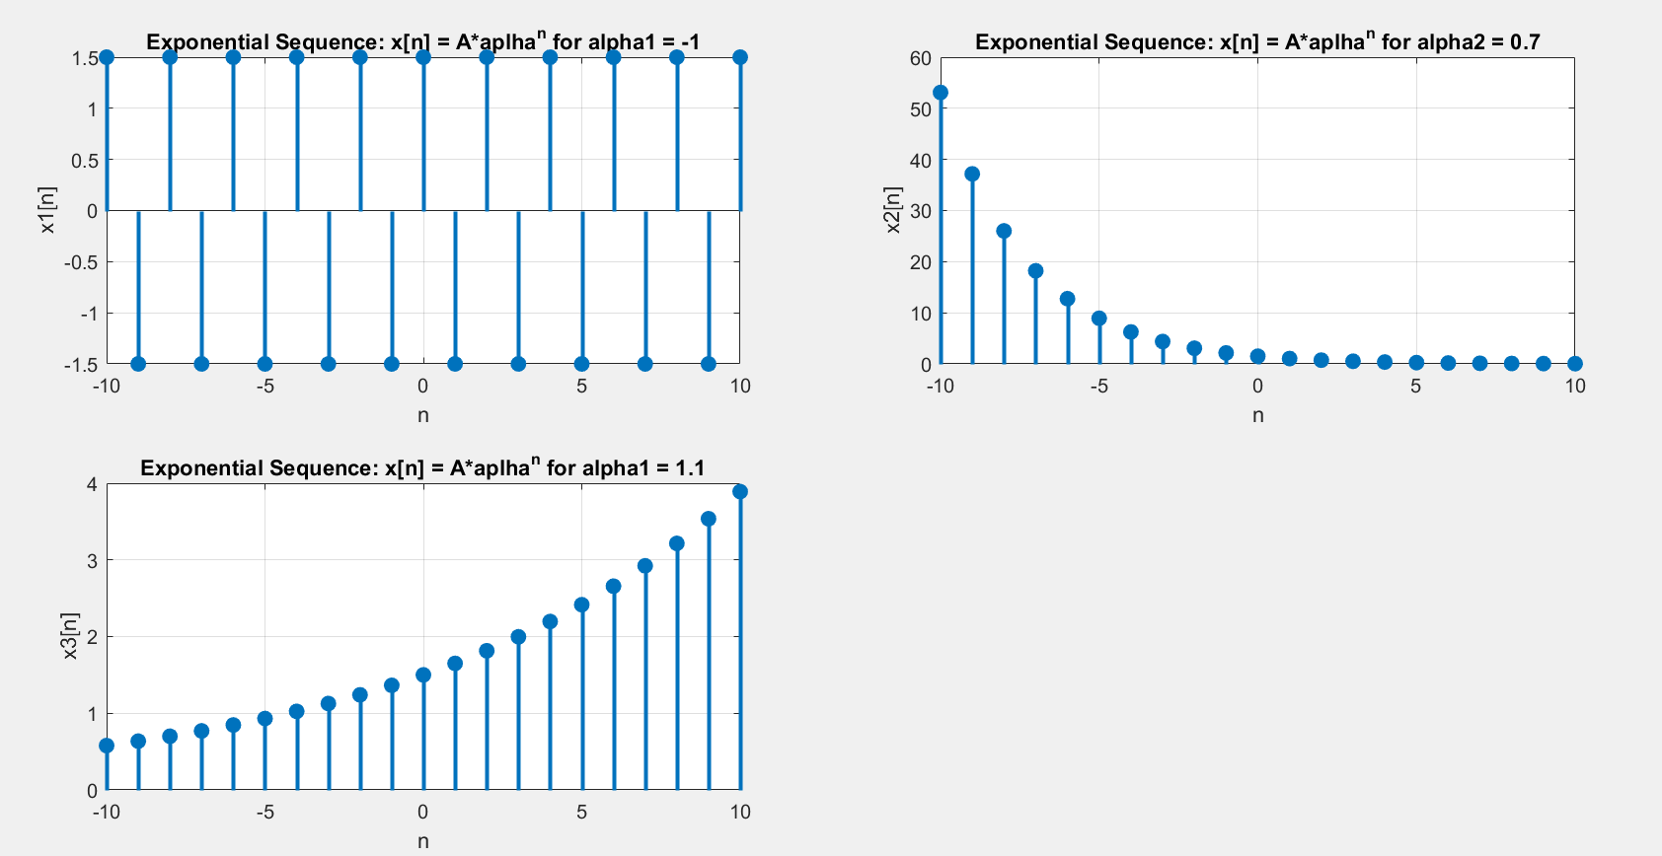

**Remarks on Output:**

First plot in above figure shows the exponential sequence for α = -1. Whenever α = -1, the exponential sequence alternates between A (for even n) and -A (for odd n).

Second plot in above figure shows the exponential sequence for α = 0.7 (0 < α < 1). It represents an exponential decay graph. The values of sequence decreases with increasing n because the increasing exponent decreases the resulting number. This is an example of convergent sequence as it is converging to zero when n approaches to infinity.

Third plot shows the exponential sequence for α = 1.1 (|α| > 1). It represents an exponential growth graph. The values of sequence increases with increasing n because the increasing exponent increases the resulting number. This is an example of divergent sequence as it diverges to infinity when n approaches to infinity.

Let A=2, n= -10 to 10

1. for (-1 < alpha < 0), try alpha= -0.5
2. for (0 < alpha < 1), try alpha=0.7
3. for (|alpha| > 1), try alpha= 1.1

**Code:**

Rest of the code same as above task.

**Output:**

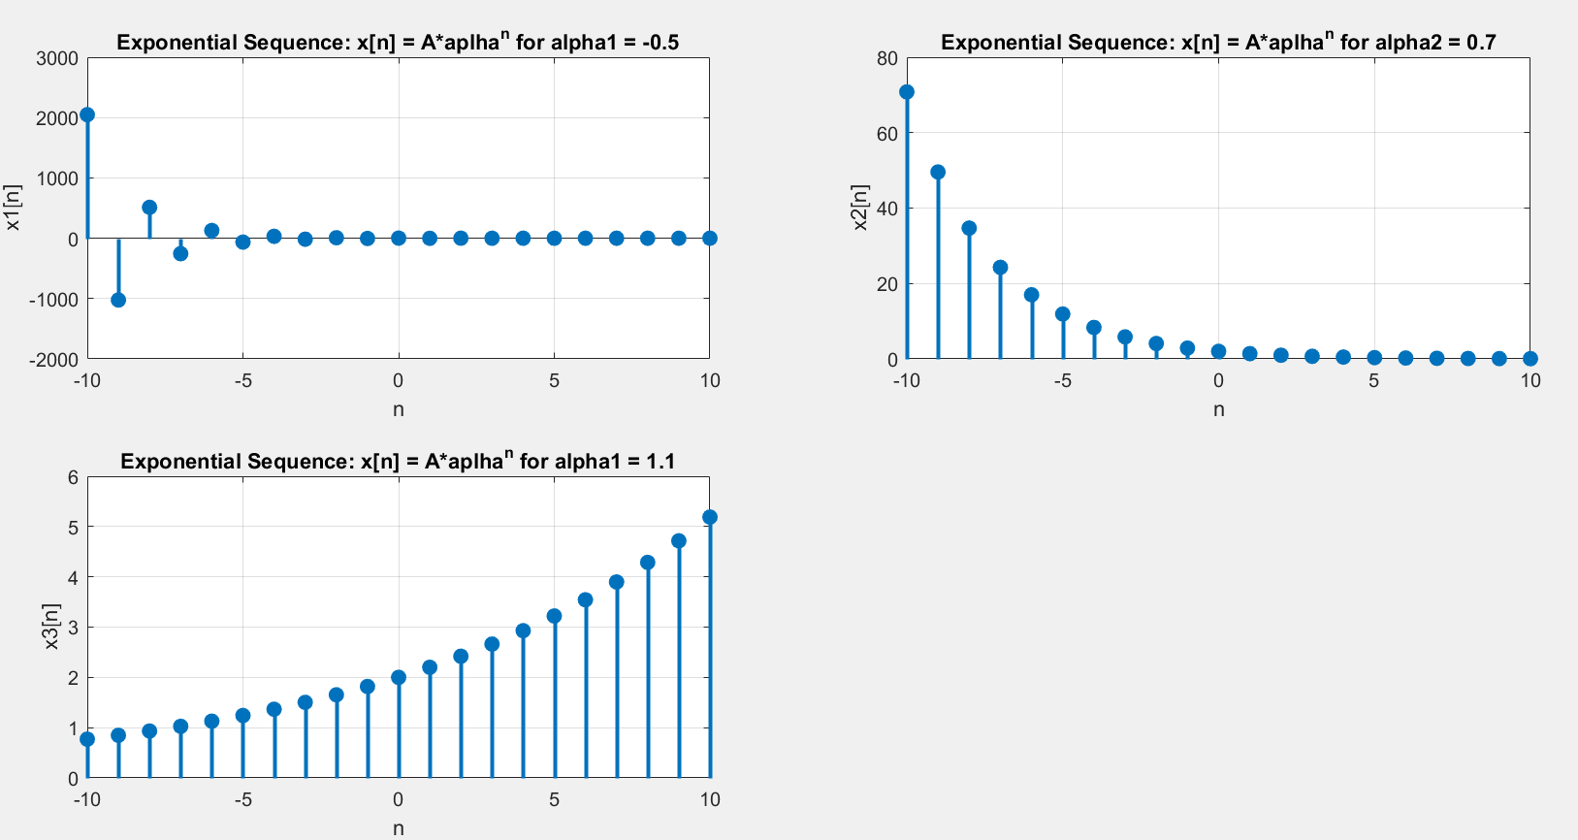

**Remarks on Output:**

First plot in above figure shows the exponential sequence for α = -0.5(-1 < α < 0). Whenever α = -0.5, the sequence oscillate between negative and positive values while its magnitude decrease with increasing n.

Second plot in above figure shows the exponential sequence for α = 0.7 (0 < α < 1). It represents an exponential decay graph. The values of sequence decreases with increasing n because the increasing exponent decreases the resulting number. This is an example of convergent sequence as it is converging to zero when n approaches to infinity.

Third plot shows the exponential sequence for α = 1.1 (|α| > 1). It represents an exponential growth graph. The values of sequence increases with increasing n because the increasing exponent increases the resulting number. This is an example of divergent sequence as it diverges to infinity when n approaches to infinity.

**Complex Exponential:**

**Code:**

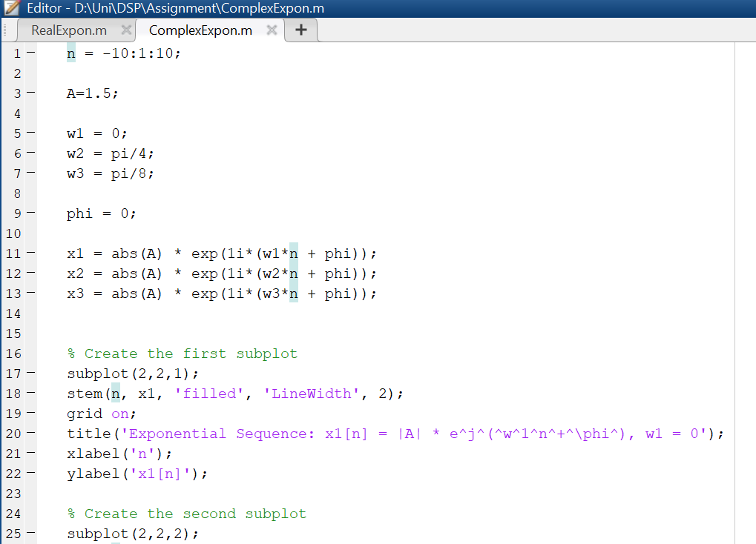

**Output:**

**Remarks on Output:**

First plot in above figure shows the complex exponential sequence for *w* = 0. The graph shows a constant function because *w* = 0 in this case.

Second and third plot shows complex exponential sequence for non-zero *w*. It forms a complex sinusoid, which has both real and imaginary parts. We can split it into real and imaginary parts using Euler’s Formula.